HIGH VOLTAGE PIEZO DRIVER (model A)

**FEATURES**

Single +24V DC Powered, 0-10V Analog Input High Voltage Amplifier

High Voltage Enable/Disable, GAIN, OFFSET, MONITORING features

Screw In Terminal Connectors, No Soldering Needed

Suitable for Capacitive Load like Piezo or Resistive Load

Metal Case with Bumpers

Active Cooling

All RoHS Components

+24V

Power Supply

**SPECIFICATIONS**

Modulation Input Analog Input 0-10V, offset adjustable, 2uF load max 200Hz Triangle Wave within driving current limit

Max Output Current ± 112 mA with 2uF load Triangle Wave

Voltage Output 0-140Vpk-pk

Cooling Active

Operating Temperature -20 – 35 C

Dimensions 55mm x 130mm x 200mm

Max Load Within max current load limit, capacitive or resistive

Bandwidth with resistive load 25KHz

Monitor Output 0-10V : 0-140V (1/50 ATTENUATION)

# Sample Results:

2.43 uF Capacitive Load with 207Hz Triangle Wave Input

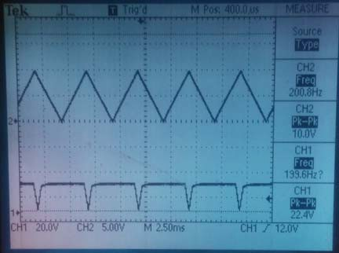

High Voltage Disable ON (ENA-RIGHT-PIN=+24V), the output is 24V with 0-10V triangle wave input

# Calculate Driving Current:

1. Modulate with Triangle Wave I = ±2*f*C_load*Vpk-pk

For example, the max current for 200Hz triangle modulation on 2uF load, 140Vpk-pk equals: 2*200*2e-6*140 = ±112mA

1. Modulate with Sine Wave I = C_load*π*f*Vpk-pk

For example, the max current for 150Hz sine wave modulation on 1uF load, 140Vpk-pk equals:

1e-6*3.14*150*140 = 66mA

ORANGE: OK, WEAK ORANGE/FLASHING: ABNORMAL

SYS LED (UPPER)

**FRONT PANEL WIRING SPECIFICATIONS**

PWR LED (LOWER) GREEN: OK

GAIN GAIN ADJUSTABLE

OFFSET OFFSET ADJUSTABLE

IN 0-10V SMALL SIGNAL BNC INPUT

MON 0-10V : 0-140V MONITOR SIGNAL BNC OUTPUT (1/50 * Vout)

HV OUT 0-140V/+-112mA RMS HIGH VOLTAGE BNC OUTPUT

+24VDC Power Supply, RIGHT PIN +; LEFT PIN return

24VDC

**REAR PANEL WIRING SPECIFICATIONS**

ENA EN: float or GND (LEFT PIN: Return)

DISABLE TIE RIGHT SIDE PIN TO +5V TO +24V

CHAS METAL ENCLOSURE, NO INTERNAL CONNECTION

FUSE 5AMP, Consult Factor Before Replace

PWR POWER SWITCH

Quotation on order of large quantity:

Email: [smartsensinginternational@gmail.com](mailto:smartsensinginternational@gmail.com)

Telephone: 978-494-0802 msg